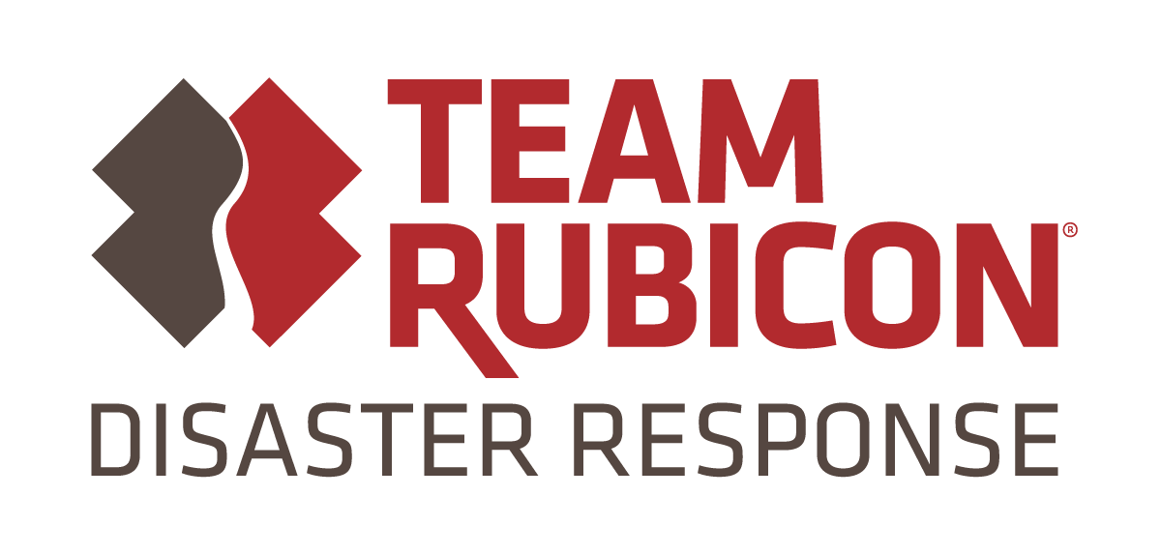
Media Contact:
Marc DeNofio
Public Affairs
Denofio@teamrubiconusa.org
518.322.5601

FOR IMMEDIATE RELEASE
Team Rubicon Commitment to Rebuild Homes in Houston is One Home Closer to Goal.
Houston, TX (November 8, 2019) – Team Rubicon, a veteran-led disaster response organization, has completed another rebuild in Houston since our program began in 2018. By year’s end, Team Rubicon expects to have returned 100 Texas families to their homes.

When Team Rubicon hands the keys to a home on Houston’s Tampa Street back to the owner today at 2:30 PM, they’ll be turning over gold. The house, which Team Rubicon rebuilt following damage from Hurricane Harvey, is the first home in Texas to earn a Fortified Hurricane Gold certification.

Developed by the Insurance Institute for Business and Home Safety (IBHS), Fortified is a set of construction standards and methods designed to help homeowners build or renovate homes to strengthen them against natural hazards like hurricanes, high winds, hail, and severe thunderstorms. Fortified, as a methodology, does not significantly change the construction materials used in home builds, but largely adjusts build methods. The result is a home more resilient to natural disasters, and likely to experience significantly less damage if it is impacted. Team Rubicon adopted the Fortified methodology for the first time this summer. The home on Tampa Street is the organization’s first U.S. retrofit to employ the standards.

Looking ahead, the organization will continue rebuild operations in communities impacted by Hurricane Harvey in the greater Houston area. Team Rubicon plans to keep building on what they’ve learned to ‘scale down’ their rebuild capability to support families and communities affected by storms that never reach the national news cycle, weather incidents that are more regularly being referred to as low attention disasters.

“For Team Rubicon, the certification is proof-of-concept; evidence that it takes only a little more time, cost, and energy to build a more resilient home,” said David Burke, Vice President of Programs and Field Operations. “We look forward to continuing to refine, grow and scale this capability. Our goal is to be in a position to help any community- large or small, urban or rural – through the full disaster cycle, from preparation to response to recovery.”

Team Rubicon is powered by a 100,000-strong, highly skilled volunteer force that helps communities prepare, respond, and recover from disasters and humanitarian crises. Since its inception following the 2010 Haiti earthquake, Team Rubicon has responded to over 390 disasters, including Hurricanes Harvey, Irma, Maria, Florence, and Michael.

Through a strong communications infrastructure supported by cutting-edge technological solutions, Team Rubicon volunteers efficiently and effectively respond to natural disasters and humanitarian crises to provide crucial support to affected communities. By giving military veteran volunteers the opportunity to continue their service through disaster response, Team Rubicon provides them an avenue to gain a renewed sense of purpose, community, and identity.

About Team Rubicon
Team Rubicon is a nonprofit organization that serves communities by mobilizing veterans to continue their service, leveraging their skills and experiences to help people prepare, respond, and recover from disasters and humanitarian crises. Programs and services are made possible by the support of individual donors, corporate partners, and the dedication of volunteers across the country. To join or support Team Rubicon’s mission, visit www.teamrubiconusa.org.
# # #

