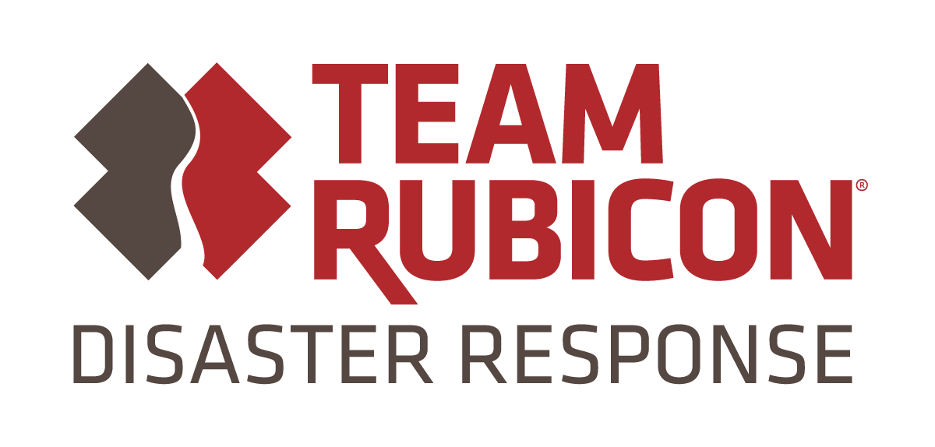 | Media Contact:  Jake McCormick  Public Information Officer  jake.mccormick@teamrubiconusa.org  530.559.1456
FOR IMMEDIATE RELEASE
"Team Rubicon will be assisting homeowners after Kincade Fire."

SANTA ROSA, Calif. (November 21, 2019) – Team Rubicon, a veteran-led global disaster response organization, is launching an operation in Sonoma County, providing property recovery services for homeowners requesting assistance after the recent Kincade Fire. Team Rubicon is partnering with Bethel Global Response, as well as coordinating with the Sonoma County Office of Recovery and Resilience, and Office of Environmental Safety. The response is expected to last five days, beginning Thursday, November 21.

"We are honored to have the opportunity to assist homeowners as they begin the healing process by recovering personal possessions lost in the Kincade Fire," said Morgan Rains, Team Rubicon's incident commander for this operation. "We look forward to partnering with Bethel Global Response as we work throughout the community, and we want to thank Cloverdale Veteran's Memorial Building for hosting our volunteers. "

The Kincade Fire ignited northeast of Geyserville, Calif., during the late evening of October 23, and was declared a state of emergency on October 25. The fire was 100% contained on November 7, and burned a total of 77,758 acres, and destroyed 174 homes. Bethel Global Response collected requests for property recovery services from a local assistance center. They requested assistance from Team Rubicon in providing this service to homeowners.

Team Rubicon boasts an over 100,000-strong, highly skilled veteran volunteer force that helps communities stabilize and recover after a devastating natural disaster. Since its inception following the 2010 Haiti earthquake, Team Rubicon has responded to over 300 disasters, including Hurricanes Harvey, Florence, Michael, and Dorian, as well as many post-fire responses in California.

Through a robust communications infrastructure supported by our cutting-edge technological solutions, Team Rubicon volunteers efficiently and effectively respond to natural disasters and help get stricken families back into their homes as soon as possible. By allowing military veteran volunteers to continue their service through disaster response, Team Rubicon helps give them a renewed sense of purpose, community, and identity.

About Team Rubicon
Team Rubicon is a nonprofit organization that serves communities by mobilizing veterans to continue their service, leveraging their skills and experiences to help people prepare, respond, and recover from disasters and humanitarian crises. Programs and services are made possible by the support of individual donors, corporate partners, and the dedication of volunteers across the country. To join or support Team Rubicon’s mission, visit http://www.teamrubiconusa.org.
# # #

